AIRBUS HELICOPTERS CANADA
TRAINING CENTRE ENROLLMENT FORM

To receive Confirmation of Enrollment on an AIRBUS HELICOPTERS CANADA AIRFRAME MAINTENANCE COURSE please complete Enrollment Form, along with *PO or Credit Card Number.
Return, attention of Saundra, by fax 905-871-3599 or e-mail Saundra.cocroft@airbus.com
Please ensure your name is inscribed the way you wish it to appear on your certificate.
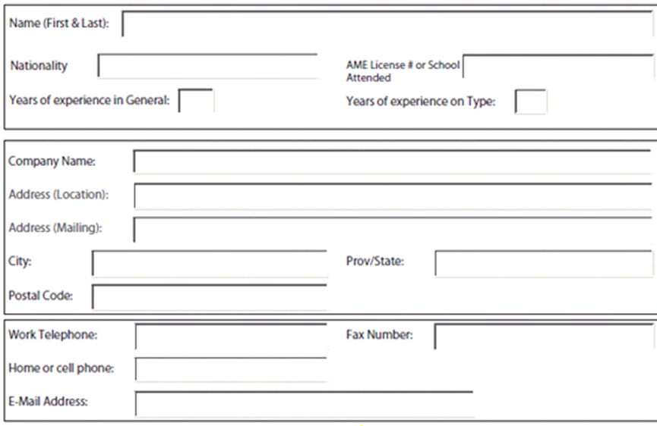
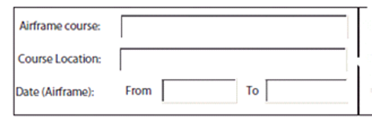
Company/Customer
*NOTE: If using credit from Purchase Order Agreement or Company PO, we require an authorized company signature on the enrollment form from D.O.M. or Owner of the Aircraft.

*Course to be provided on Purchase Order Agreement *Company PO ___________________
Please supply Aircraft Serial Number_______________ D.O.M./OWNER Signature ___________________
D.O.M./OWNER Signature________________________
Cancellation of Enrollment: Cancellations received more than 10 business days before the start date will avoid tuition assessment. No-Shows and Cancellations received less than 10 business days before class date will be assessed full tuition charges for that class.
Important: All cancellations must be in writing

- A pre-requisite for all Difference Courses is an AS350 or AS355 Endorsement

