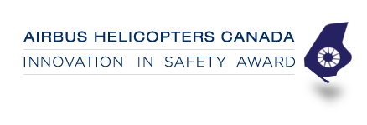

Nominee’s Company/Organization or Individuals Name:

Nominated by (please also include your place of employment):

Reason for nomination (please provide as much detail as possible to meet eligibility criteria for safety and innovation):

Please return your completed application to Laura Senecal at laura.senecal@airbus.com by Friday, October 5th, 2018.

