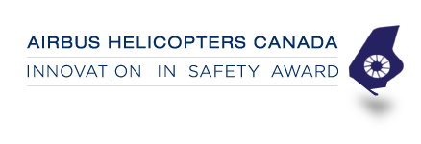

Nominee’s Company/Organization or Individuals Name:

Nominated by (please also include your place of employment):

Reason for nomination (please provide as much detail as possible to meet eligibility criteria for safety and innovation):

Please return your completed application to communications-ahca@airbus.com by Tuesday, October 15th, 2019.

